
VPN Access Instructions
- Click the Global Protect VPN client icon in the task bar in the bottom right-hand corner of your screen.

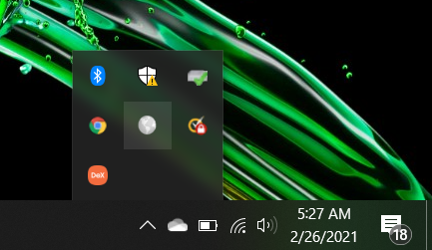

- When the Global Protect client interface appears, please click ‘Connect’.

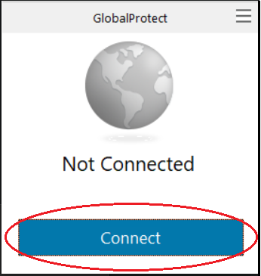

- You will receive an SMS text message on your mobile device with a numerical code.

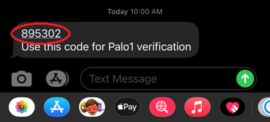

- Enter the code into the ‘Sign In’ pop-up box that appears in the client and click ‘OK’.
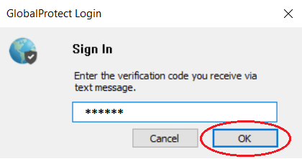

- You should now be connected!
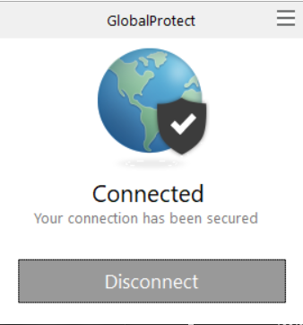
Coaconnect.atlantaga.gov

