How to print Postcards in Benchmark

Adding a Xerox Printer
If the printer you want to print postcards needs to be added to your computer. Administrator access is needed for this step. Please contact Desktop Support if needed.
- Run the AltaLinkB80xx_7.76.0.0_PS_x64 or VersaLink_B7025_B7030_B7035_7.95.0.0_PS_x64. It can be found in the shared Installs folder on the Benchmark application server or on the Xerox website (When choosing a driver, select the Postscript Print Driver for Administrators
- Select the proper printer and follow the Xerox instructions
  - Warrants
    - Xerox AltaLink B8055 V4 PCL6
Serial No. Y4X846463
IP: 10.18.110.247
Name: XRX9C934E9669B5
    - Xerox Versalink B7035 - 4 Tray
Serial No.5DA843534
IP: 10.18.111.28
  - Data Entry
    - Xerox AltaLink B8055 V4 PCL6
Serial No. Y4X843942
IP: 10.18.111.26
Name: XRX9C934E96525D
  - Pre-Trial
    - Xerox AltaLink B8055 V4 PCL6
Serial No. Y4X845668
IP: 10.18.120.226
Name: XRX9C934E9661DA

Checking Printer Permissions
In order to print postcards the computer you are using must be setup to allow the following permissions to everyone for the printer being used. This can be checked in the printer settings. One method of steps to get to your printer settings is:
- Type printer in your windows search box
- Select the Printers & scanners
- Select the printer you will be using to print the postcards
- Select Manage (If you do not see the Mange button, Desktop Support will need to provide permissions)
- Select Printer properties
- Select the Security tab
- You should see the following permissions allowed for Everyone
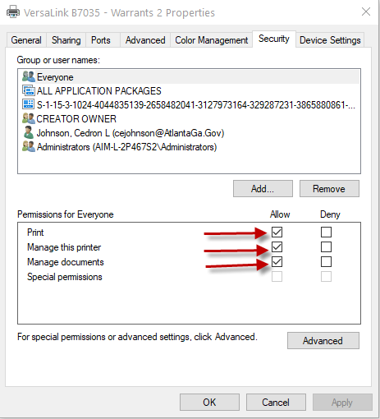
- If all 3 permissions are not allowed for Everyone, contact Desktop Support to provide
- If all 3 permissions are allowed you can select OK and proceed with the following instructions
- The steps above only need to be done once per printer on this computer. However, it will need to be done once for each printer that will be used to print postcards from this computer

Setting printer default and postcard settings
Before printing postcards, you will need to make the printer you are printing the postcards your default printer. This is done by the following steps:

- Type printer in your windows search box
- Select the Printers & scanners
- Select the printer you will be using to print the postcards
- Select Manage
- Select Set as Default
- Next make sure the printer is set to print the postcards and selecting Printing preferences and follow the steps below:
For the HP M402dw printer
  - Set the paper size to 4 x 6
  - Set the media or paper type to Heavy
  - Set the Orientation to Landscape
  - Select Apply
  - Select Ok
  - Close the printer and scanner windows
  - Place postcards in tray 1
For the Xerox AltaLink B8055 printer and Versalink B7035 printer
  - Under the Print Options tab
    - Set Job Type to Normal Print
    - Select the Paper drop down and Other Size
      - Set Fit to New Paper Size to A6
      - Change Paper Size to A6
      - Set Other Type to Cardstock
  - Under the Document Options tab
    - Set Orientation to Landscape
  - Set media or paper type to card stock if available
  - Select Ok
  - Close the printer and scanner windows
  - Place postcards in tray 5 for the Altalink or tray 4 for the Versalink
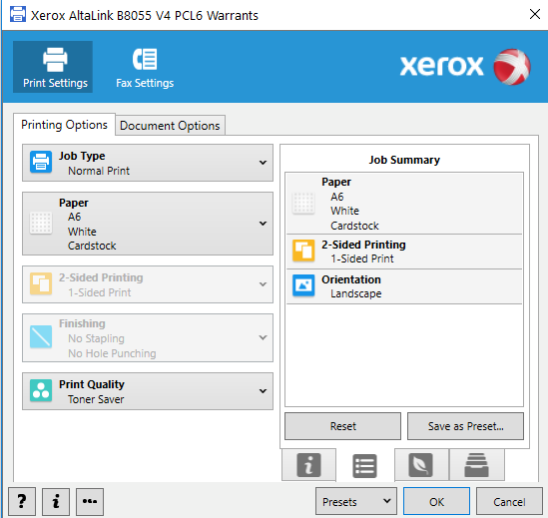

- Now open Benchmark. If you already have Benchmark open, Select File > ReLog

- Now you can follow your normal process to open your cases to print. When going through your normal print process, you will now see two print options with one ending with Xerox. The print option ending with Xerox should be used if printing to the Xerox printer and the other is to be used when printing to the HP M402dw printer.

- When the print window is open, the print view should accurately show one record at the size of a postcard. If the view looks like letter size or shows multiple records, then your printer preferences are not saving. You may want to select the properties button to confirm the settings saved.

Once you finish printing postcards you can follow the steps above to change your default printer for normal use if necessary.

