How to join a Mac to the Atlanta Domain

1. Login to the Mac as an Administrator.

2. Open 'System Preferences' select 'Users & Groups'
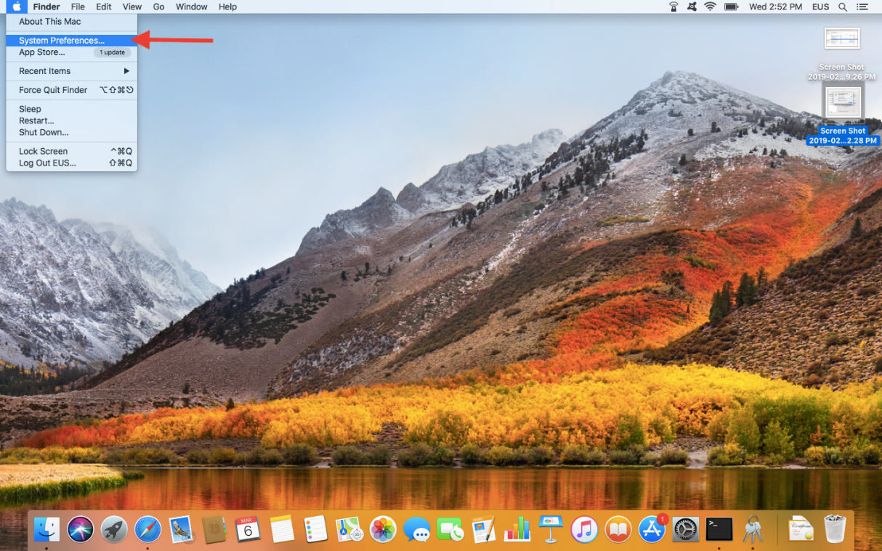
3. Select “User Groups”
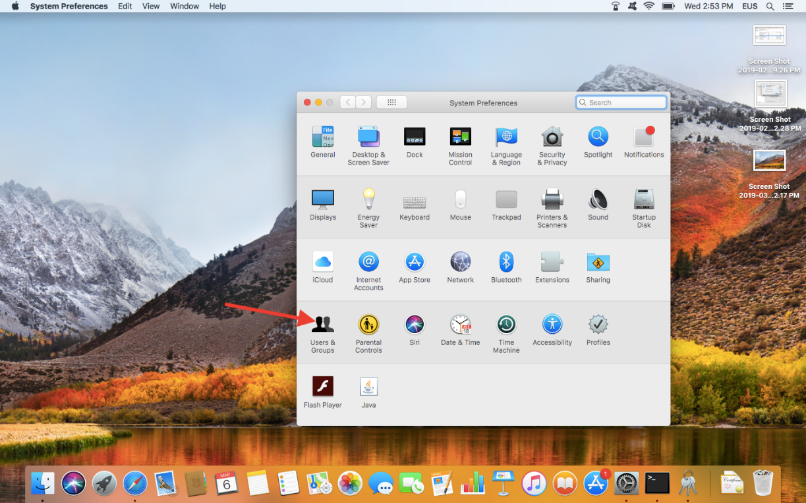

4. Select the 'Login Options' menu in the sidebar
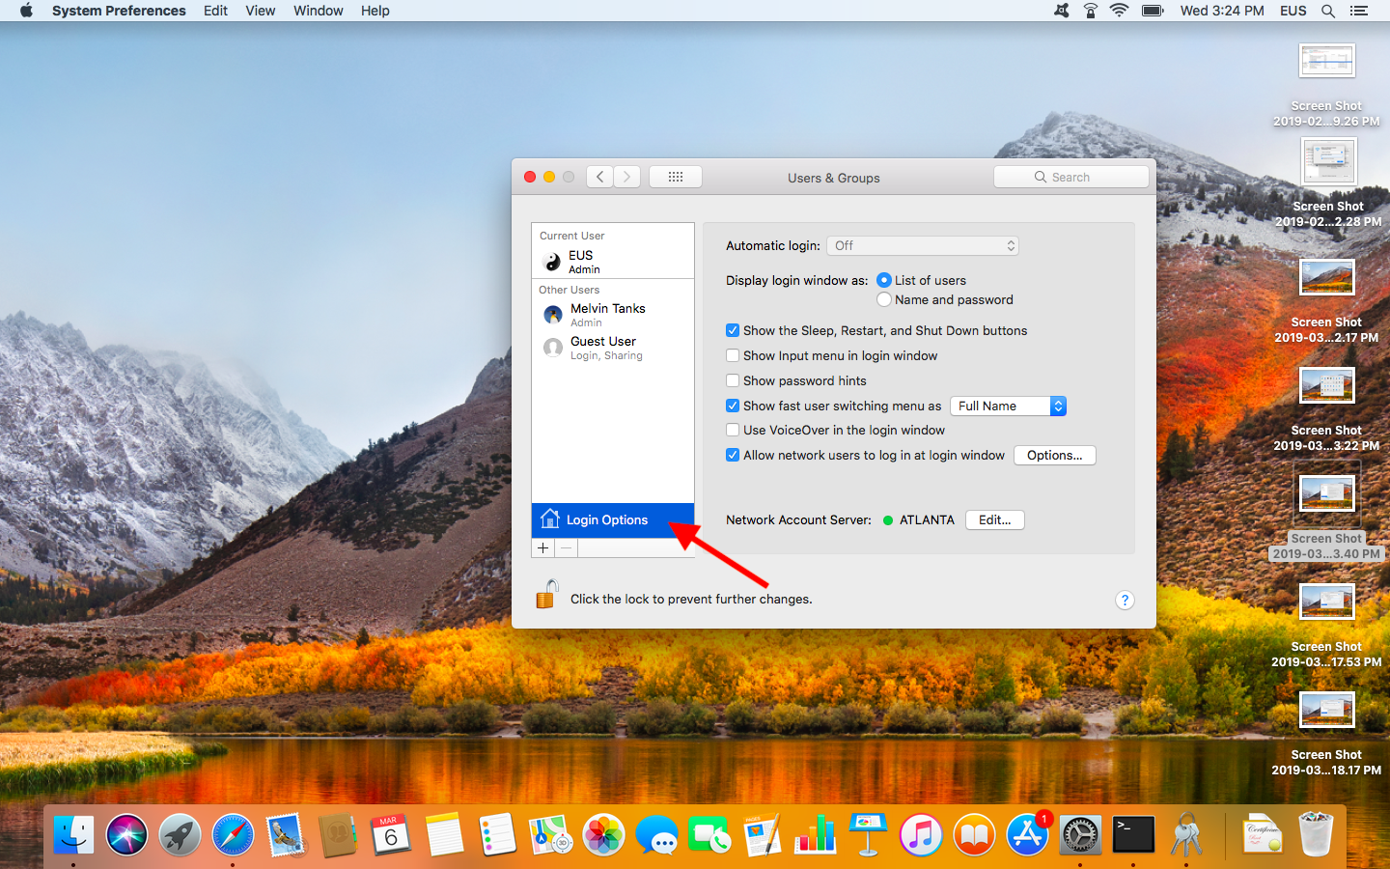
5. Use the “Join” button.
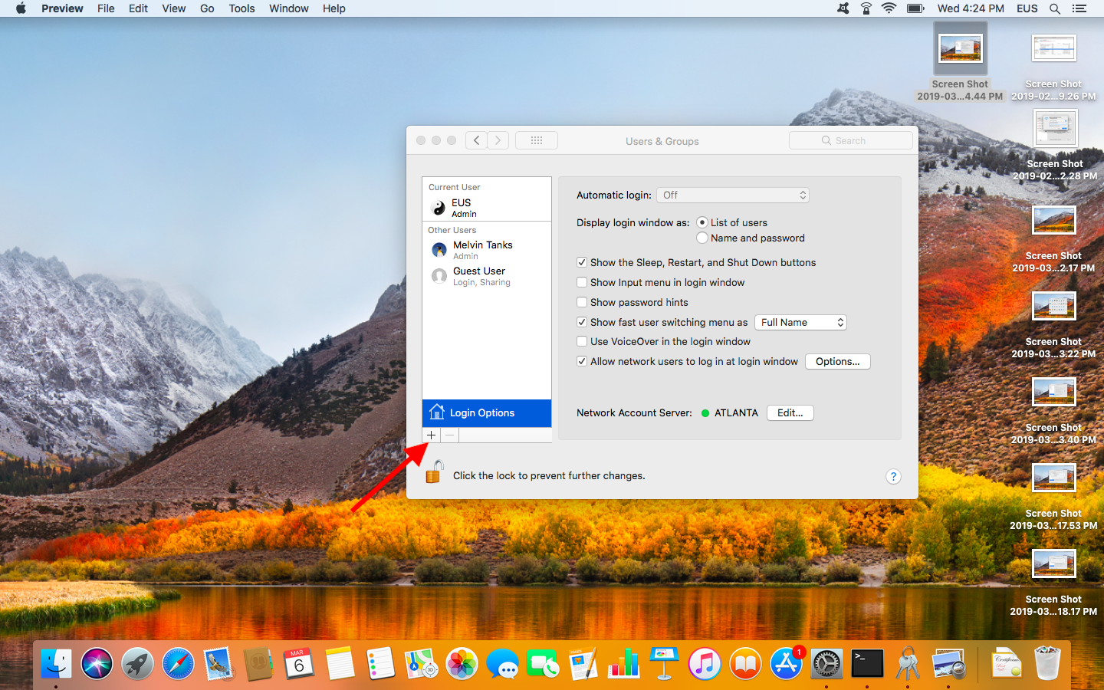

6. Enter the fully-qualified domain name of the AD domain being bound.
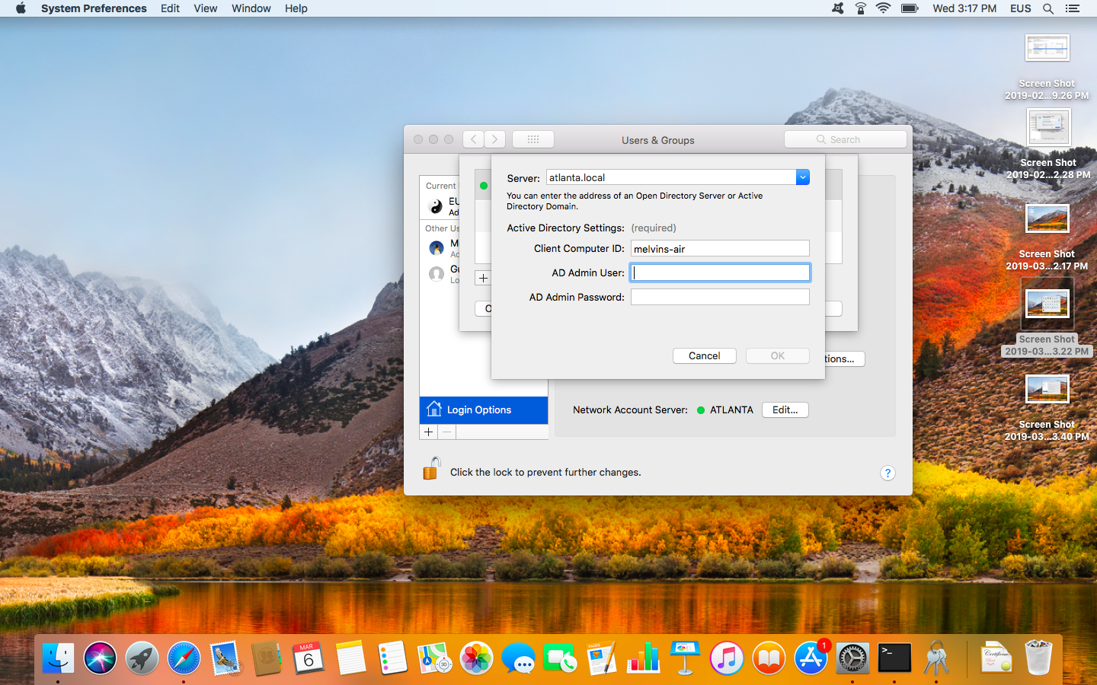
***AD Domain level credentials will be needed***

