We're Redefining IT For Small Business

Stop settling for one size fits all IT, and find your just right solution.
We’ve worked with a variety of professionals and have recognized that small businesses seem to be stuck with either insufficient IT or an oversized, generic solution that doesn’t fit their unique needs. We consult with you and your team to find the right combination of IT strategies built to fit for your needs, instead of applying blanket solutions.

Outsource your technology worries and focus on running your business.
We know companies like yours inside and out, and can easily identify solutions for common technology pain points. Our team of experts handle management of hardware, networking, security and more so you can focus on what you do best—running your business.

Work With an IT Team Focused on You

Our clients are more than just a number on a support ticket.


We’re local and build personal relationships with each of our clients.
We get to know you, your team and your business. From day one we work one-on-one with your team to find the best IT solution for your business. Our responsive and approachable team are always a phone call or mouse click away to support your team.

Our Services

We do it all and can handle any technogy growing pain you throw at us.
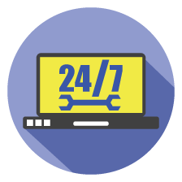

Client Portals
Our client portal puts valuable resources at your employees’ fingertips.
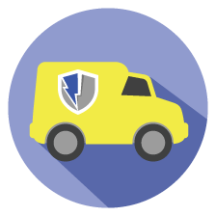

On-Site Support & Emergency Response
Not all IT issues can be resolved remotely. That’s why we offer our clients onsite support and emergency response.


Server & PC Management
Our server and PC management services, help your business function without costly interruptions.
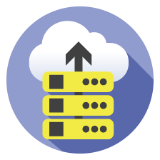

Server Backup Solutions
Our cloud backup solutions protect your company’s servers and information.


Help Desk
Our help desk features a fast response time that allows your employees to get their issues resolved as quickly and effectively as possible.
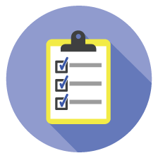

IT Strategy
Learn about our IT strategy services, which help your business anticipate issues before they happen.

Data Security in Atlanta Downtown

Your data is the crown jewel of your business — treat it with the respect it deserves
Information powers your business, and natural disasters, malicious attacks, or user errors can impair (or even halt) day-to-day operations. A focus on data security in Atlanta can be the difference between success and failure. Professionally managed data is the key to business growth — and significant downtime can severely affect that.

Don't leave your business at risk — protect your data now
Hackers have declared war on businesses everywhere, and ransomware is their preferred weapon. By locking users out of their data and demanding payment to regain access to it, hackers have extorted billions of dollars from businesses of all sizes. 67% of ransomware targets are small to medium-sized businesses with sub-par IT security. Don’t let your business be next. CMIT Solutions knows data security in Atlanta. Let us protect your interests.
Leveraging our national footprint and close partnerships with industry leaders, CMIT Solutions brings SMBs the best backup tools, protection, and data security in Chicago.

