Copier Email Setup

The new Setup requires configuring a service account in the copier as well as setting it up with a password.

The following accounts user name should be used.

User name is case sensitive make sure you type it exactly as you see it here

svc_COA_Xerox@atlantaga.gov = for all others
svc_DWMAtl_Xerox@atlantaga.gov = Watershed
svc_APD_Xerox@atlantaga.gov = APD
svc_CityHall_Xerox@atlantaga.gov = CityCall

The password for all the accounts is Copier_Service2020!

You’ll need to click Save on each tab before moving to the next.

Navigate to the email settings on Copier Admin Portal and edit the SMTP settings.

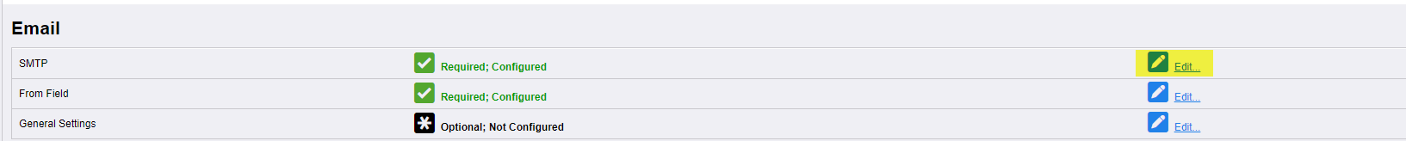

Update Highlighted areas and Save on the Required Information tab.

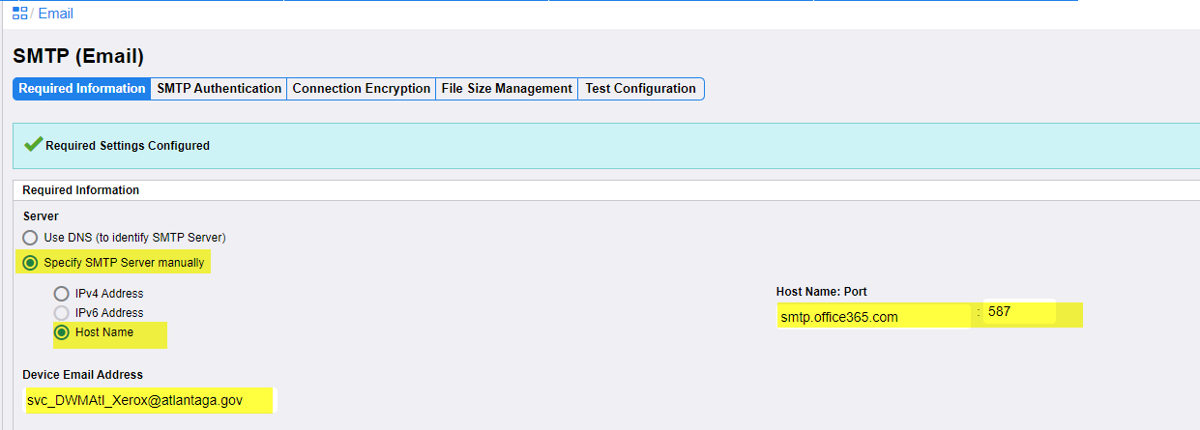

Update Highlighted areas and Save on the SMTP Authentication tab.

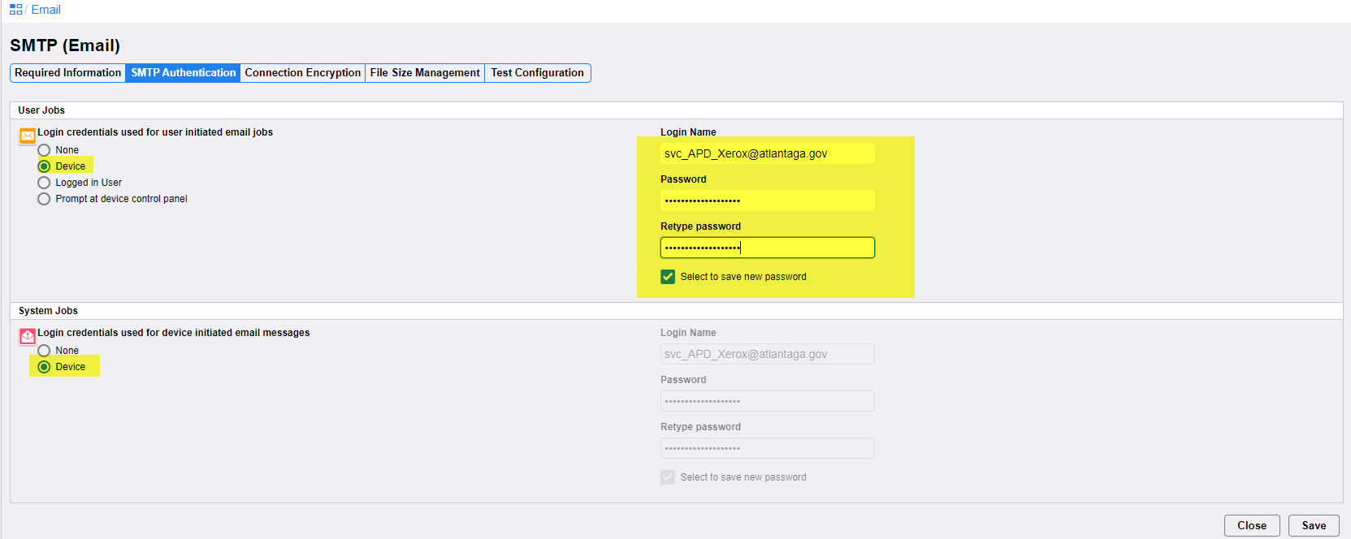

Update Highlighted areas and Save on the Connection Encryption tab.

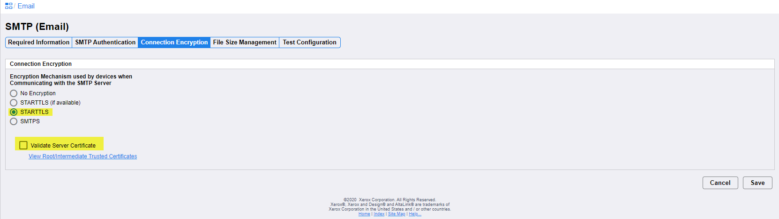

Attempt a Test connection.

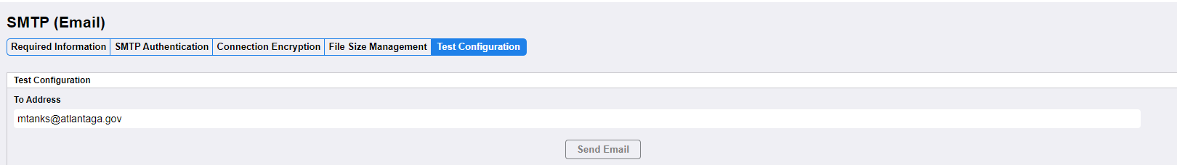

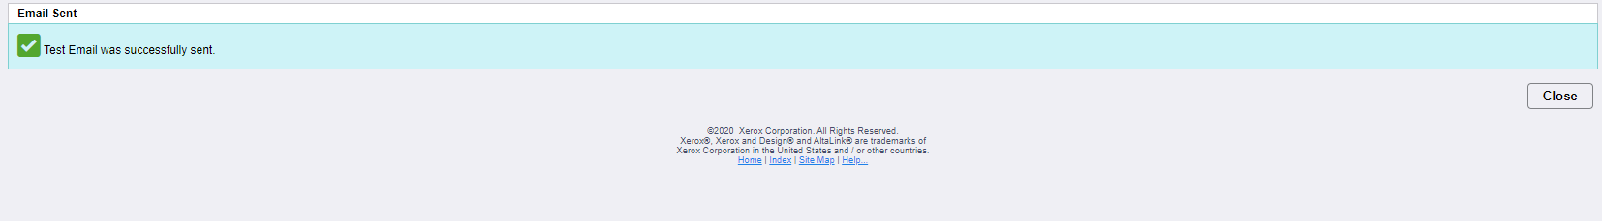

From Email Setting Edit the From Field with the account name.

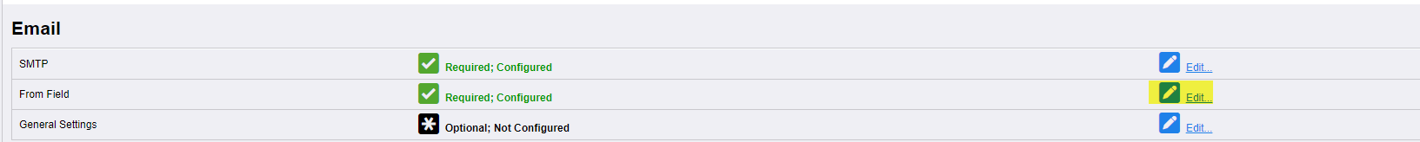

Update Highlighted areas and Save on the next tab.

