Installing Anywhere Warrant EWI Application
This document will provide instructions and troubleshooting for the Anywhere warrant application. Install can be done via ConnectWise
For errors in installation, skip to step 6
- You will need the users computer name to push the installation script to the computer from the ConnectWise Command Toolbox
- Search the computer name:
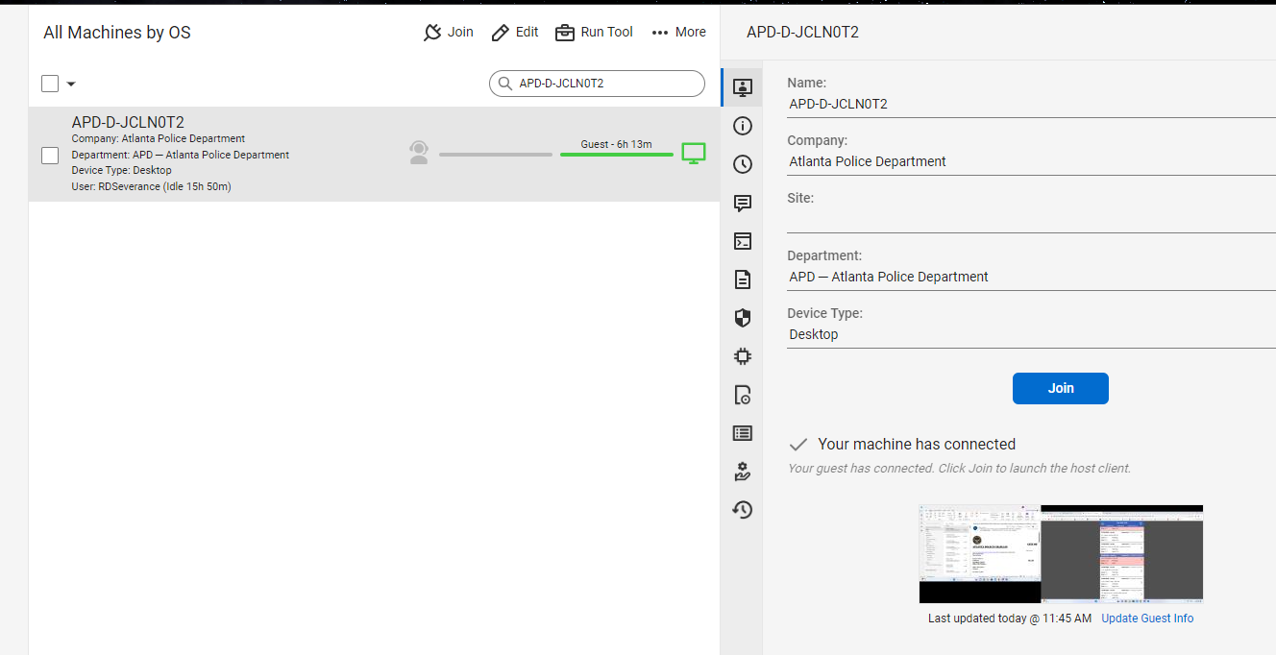
- Right click on the computer name and select ‘Command Toolbox’
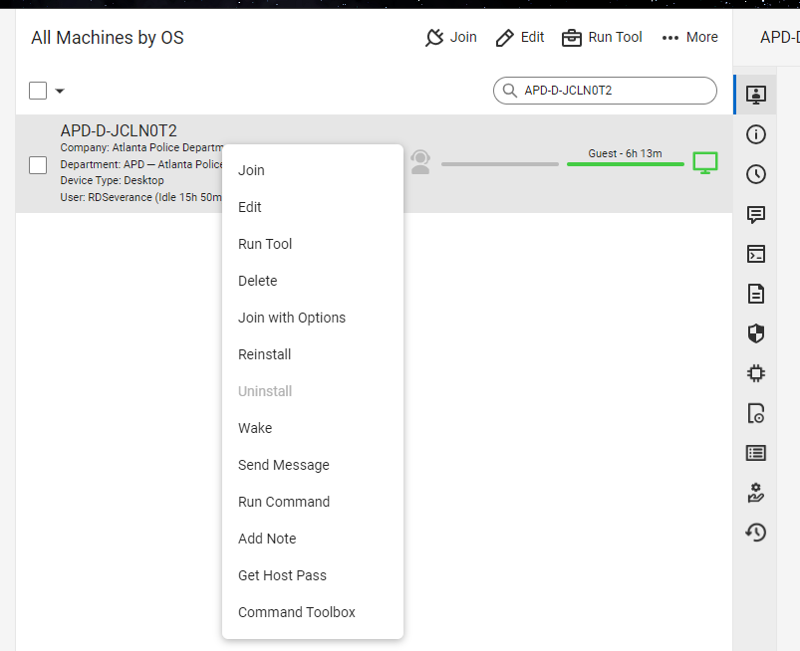
- Click the drop down box and select ‘Install EWI Anywhere Warrant Launcher‘ then click ‘Run Command’
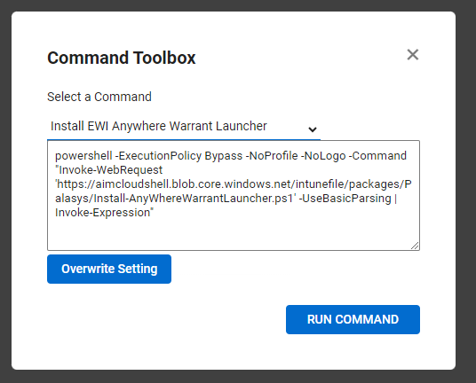
- Check the status of the install by clicking the ‘Commands’ button.
You must advise the user that two pop-ups will appear during install, and to click ‘OK’ on both
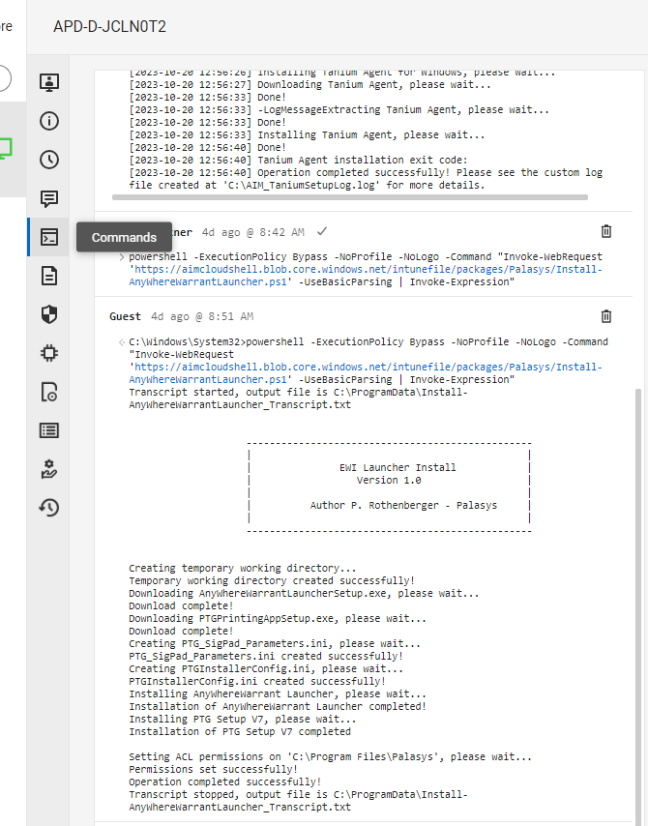
Output for successful install
- If you see this message in the ‘Commands’ display, it means that the application did not install completely. Below are steps to fix this issue: 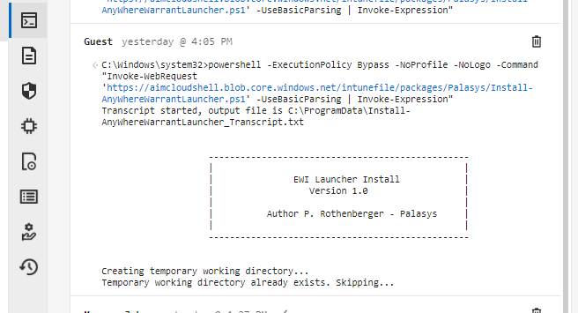
- You will have to remote into the users computer and delete the directory C:\ProgramData\Palasys. You will need to use your T2 credentials for this action. The folder ‘ProgramData’ is a hidden folde, so you must type it in manually in the file explorer:
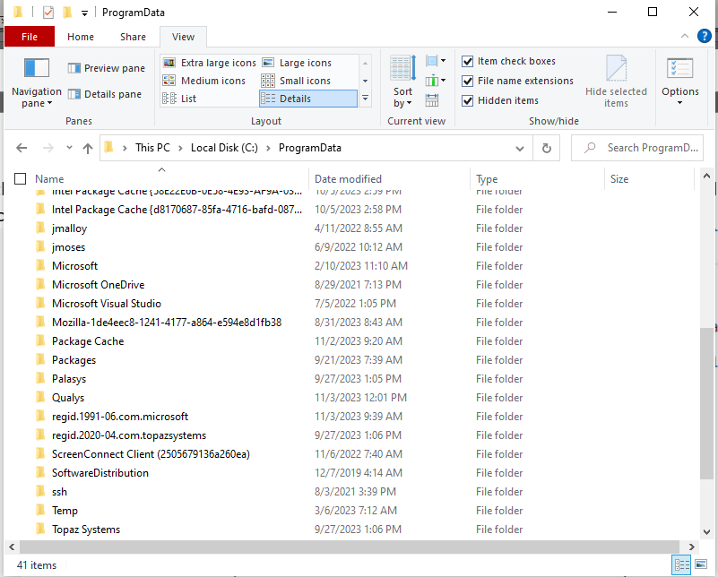
Delete this folder
- Go back to setp 3 and run the script again. The install should succeed now.

