Instructions for Sending an Electronic Fax

To send an e-fax:
- In the “To” field enter the 10-digit phone number @fax.atlantaga.gov
Example: +14045551212@fax.atlantaga.gov or +18005551212@fax.atlantaga.gov
- In the “Subject” field you may type the recipient’s name.
- Click on “Attachments” and attach documents to fax.
- Hit “Send”
Fax server processes and fax arrives at user’s location with no visible change from ordinary fax.

To receive an e-fax:
- The sender from the outside uses a fax machine, and sends to your assigned number, with no visible change in the process.
- The fax server processes the fax and sends it to your desk as a PDF attachment in your mailbox. The e-fax will appear in mailbox from “Faxination Service “
- The document now may be faxed to someone else or forwarded as an email.

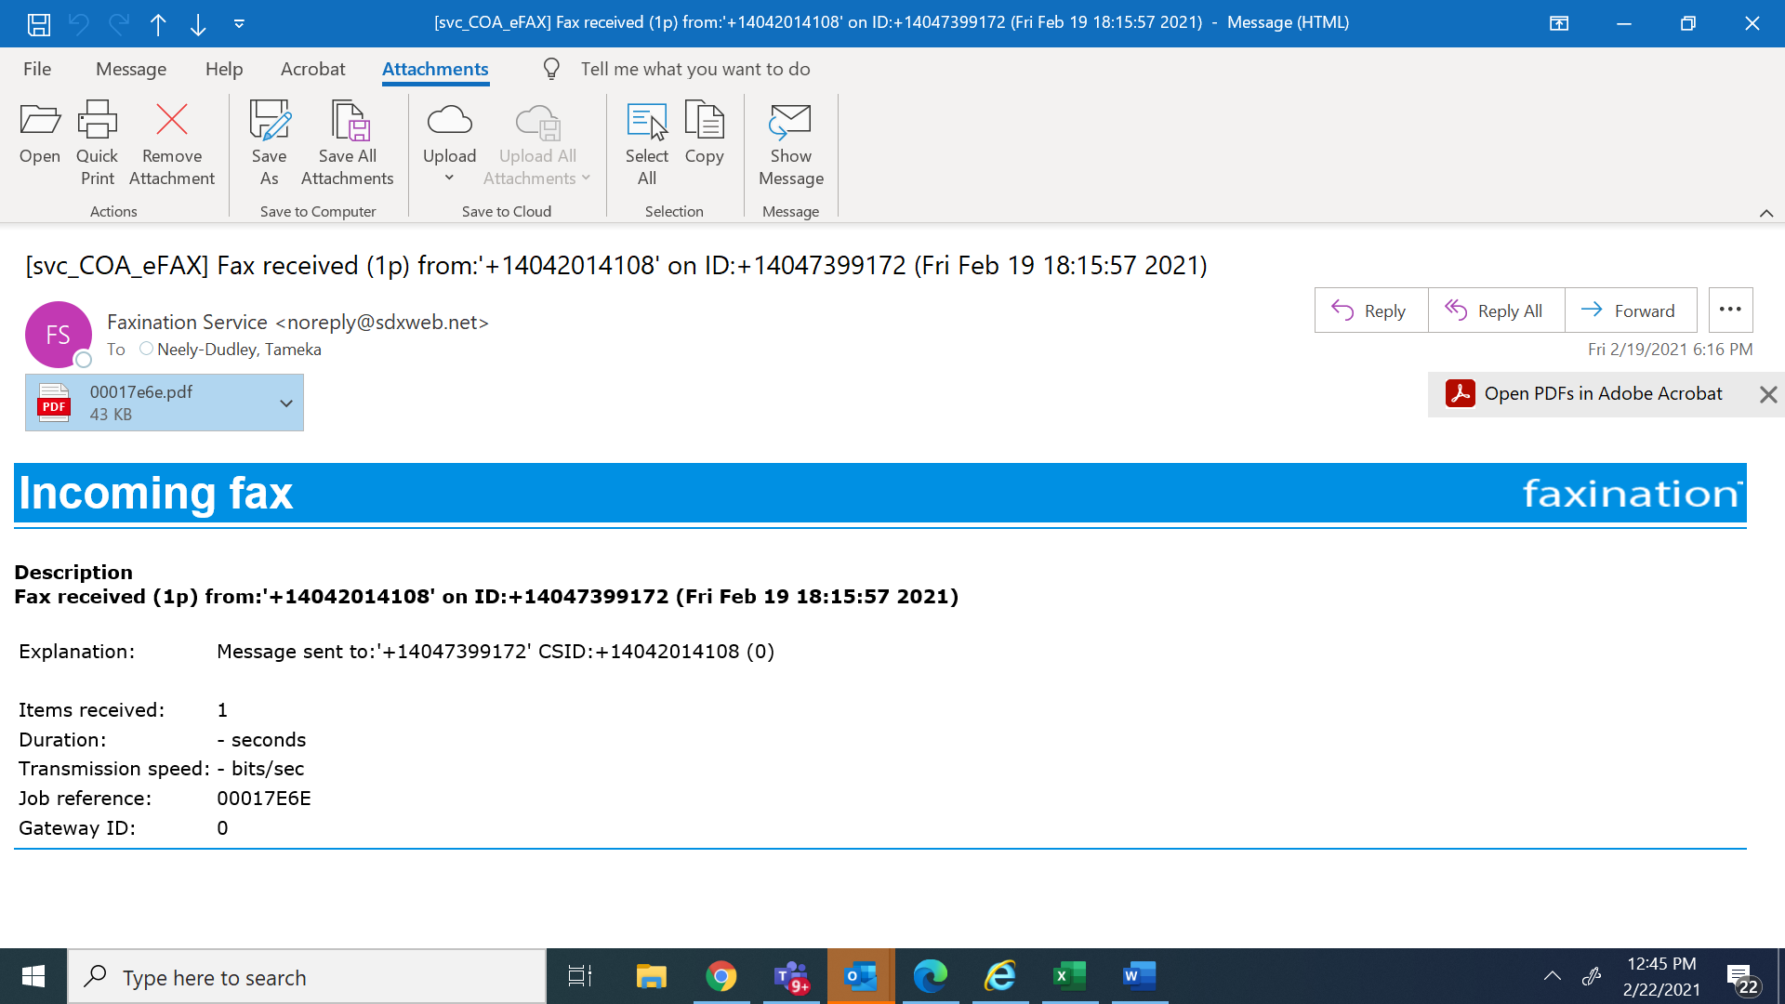

Retrieving E-fax Numbers for City Employees
- Go to and click on address book.
- Type in the name of the person you wish to retrieve.
- Click on their name, select “Phone/Notes”, number is listed under fax

