How to Fix 'Outlook Data File has reached the Maximum Size'​



Stellar Information Technology Pvt. Ltd.

18,284 followers
Follow
June 28, 2022
Open Immersive Reader
Outlook data files, such as Personal Storage Table (PST), store a copy of the mail items, including attachments, on your local system. As you send and receive more emails, the PST file grows larger with time and usage.
Although a Unicode PST file can grow as large as 50 GB in Outlook 2013, 2016, 2019, and 2021, the maximum recommended size limit for PST file is 20 GB to ensure consistent Outlook performance and prevent PST file corruption due to oversizing. This is why administrators often set a maximum PST file size limit via Group Policy or manually.
When PST exceeds this set limit, it cannot hold or store more mail items, and Outlook displays errors such as “Outlook data file has reached the maximum size” or “Outlook.pst file has reached the maximum file size limit.”
Below we have mentioned the solutions to resolve the Outlook data file has reached maximum size error. You can either increase the default PST size limit to store more data or remove old or non-important mail items from the PST file to create space for newer mail items.

Solutions to Resolve Outlook Data File Has Reached the Maximum Size
You can follow the below-given methods to resolve the issue.

1. Compress PST File
Outlook provides an option to compact the Outlook PST data file, which essentially compresses the PST file by removing the white space or space left by deleted mail items. By compressing the PST file, you can resolve the Outlook data file has reached the maximum size error.
The steps are as follows:
- In Outlook, navigate to File > Account Settings > Account Settings.
- Click on the “Data Files” option and select the PST file associated with your email profile from the list.
- Double-click or click Settings and go to Advanced.
- Click the “Outlook Data File Settings…” option.
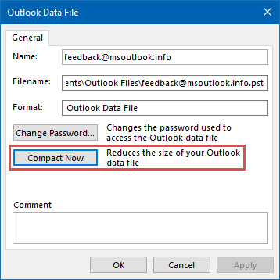
- Click on the Compact Now button.
This will remove all the whitespace from the PST file and may reduce the file size.

2. Archive Old Mail Items
Archiving helps you significantly reduce the mailbox and PST file size. It saves the older mail items in a new local PST file with attachments. This is a convenient option to backup old mail items while making space in the PST file for new items.
The steps are as follows:
- Open Outlook and navigate to File > Info > Cleanup Tools > Archive.
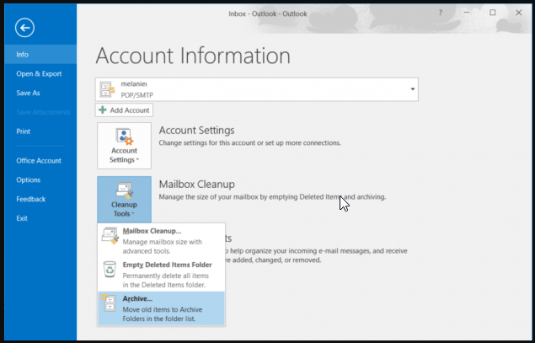
- Choose the mail folders from where you want to archive old items and then choose the date in Archive items older than.
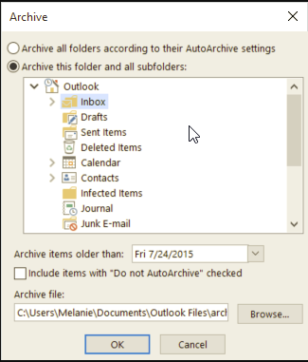
- Click Browse to choose a save location where the mail items will be saved in a new PST file.
- Click OK.
Microsoft Outlook will start archiving the emails received or sent before the selected date and save them in a local PST file. Thus, all your mail items remain accessible from Outlook. However, you can’t access the archived emails from Outlook web.
On the positive side, this will significantly reduce the PST file size, resolve the ‘Outlook data file has reached the maximum size’ issue, and make space for new items.
Alternatively, you can use Outlook Import/Export wizard to export and save the mail items from your mail folders to a PST backup file and then delete the items from your Outlook to reduce the .pst file size.

3. Save Attachments in a Different Folder
Attachments contribute most to the size of a PST file. If you often send or receive emails with attachments, your PST file may quickly grow large and exceed the limit, leading to the Outlook data file has reached the maximum size error.
To create more space in the PST file, you can find emails with attachments and save the attachments in a local folder, external drive, or cloud. After saving the attachments, you can delete them from the email to reduce the PST file size to store more mail items.
The steps are as follows:
- In Outlook, click on the filter below the search bar.
- From the available options, click Size to sort emails based on size.
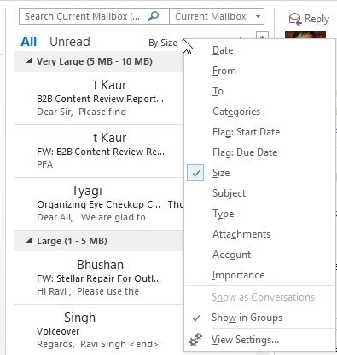
- Click Largest to list emails in descending order (large to small).
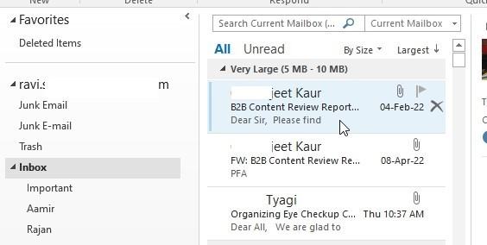
- You may open each email individually and save the attachment to a local drive using the Save All attachments… option.
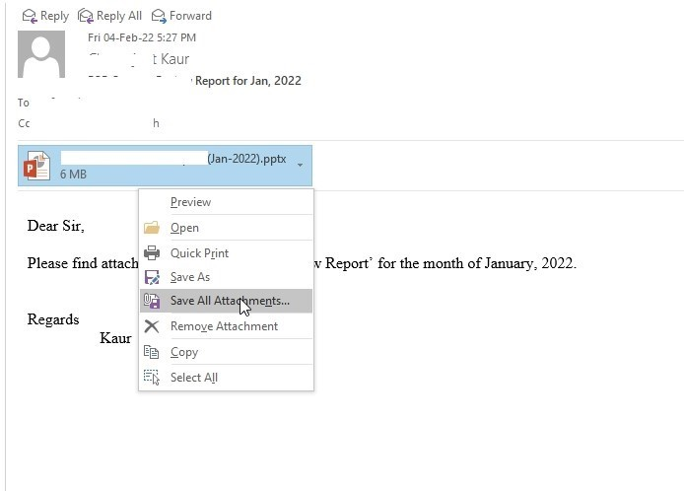
- Then right-click on the attachment and choose “Remove Attachment” to delete the attachment from the email.
- You may also delete the mail item if you don’t need it anymore.
This will help you significantly reduce the mailbox or .pst file size.

4. Increase PST File Size Limit (Advanced Method)
Instead of reducing the PST file size, you may also increase it to resolve the Outlook data file has reached the maximum size error. This is an advanced method that involves editing the registry keys. The solution isn’t recommended if you have never edited registry keys, as any mistake can lead to a system error and may require you to reinstall Windows.
The steps to increase the PST file size are as follows:
- Close Outlook and press Windows + R.
- Type regedit and click OK or press the Enter key.
- This will open the Registry Editor window.
- Based on your Outlook version and edition, navigate to the following locations in the Registry Editor window.
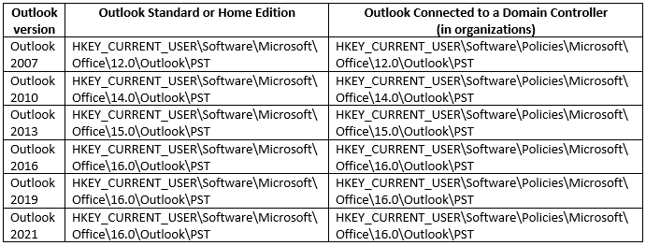
- Look for the PST key. If it doesn’t exist, right-click the Outlook key and choose New > Key. Name this key PST.
- Inside the PST key, right-click and choose New > DWORD (32-bit value). Create two values: MaxLargeFileSize and WarnLargeFileSize.
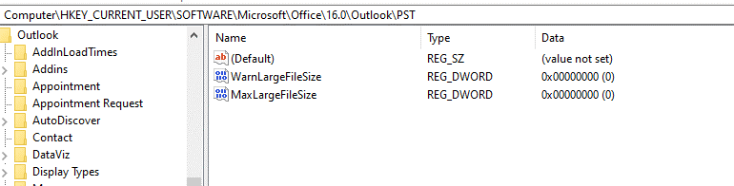
- Double-click on the MaxLargeFileSize and enter the following decimal value:
- 51,200 for 50 GB or 40960 for 40 GB. Convert GB to MB and enter the MB value and click OK.
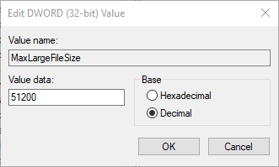
2. Similarly, add the WarnLargeFileSize decimal value slightly lower (90-95%) than the MaxLargeFileSize. For instance, if you enter 51200 in MaxLargeFileSize, enter 48640 value in WarnLargeFileSize and click OK.
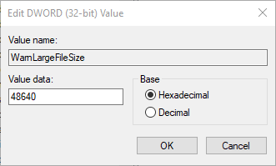
- Once updated, close the Registry Editor window and start Outlook. The error Outlook data file has reached the maximum size should be gone now. However, it may re-appear once the PST reaches the newly set limit.

To Wrap Up
By following the solutions and workarounds discussed in this article, you can resolve the Outlook data file has reached the maximum size error. You can either increase or reduce the PST file size to fix the error. However, we recommend reducing the PST file size as oversized or large PST is prone to corruption and damage. It may also lead to Outlook performance issues.
In case the PST file gets corrupt or damaged, you can use SCANPST or an advanced Outlook PST file repair software, such as Stellar Repair for Outlook, to fix the PST file damage or corruption. Use SCANPST for PST files with minor corruption and size smaller than 2 GB. If SCANPST fails or the file is large, use the Outlook repair tool to fix the damage and get back access to all your mail items.
Report this

Published by

Stellar Information Technology Pvt. Ltd.
18,284 followers
Published • 1y
Follow
Outlook users may come across the error "Outlook Data File has reached its maximum size limit" and due to this error, you can't work on Outlook efficiently, you might be unable to access Outlook or unable to send/receive new emails. You can easily fix this issue by yourself by using one of the methods: 1. Compact PST File 2. Archive old mailbox items 3. Save attachments in different folder 4. Increase PST file size limit Please read this article to know how to perform the above solutions to fix the issue. As an oversized PST file is prone to corruption, you can also fix the oversized PST file and recover the lost data using a third-party PST Repair tool in case of data file corruption. #pstrepair #microsoftoutlook #outlookrepair #recoveroutlook #softwaresolutions #fixOutlook #outlookpstrepairtool #outlookpstrepair #outlookpstrecoverysoftware #fixOutlookerror #outlook

