Step 1: Go to https://coaconnect.atlantaga.gov
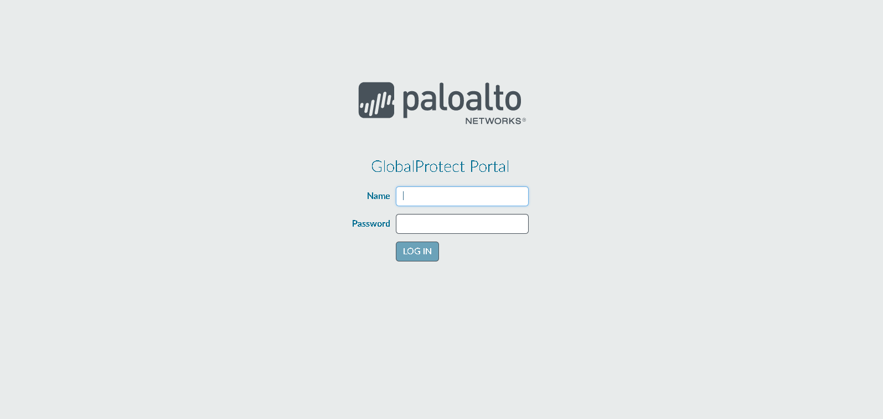

Step 2: Login with your Network Credentials
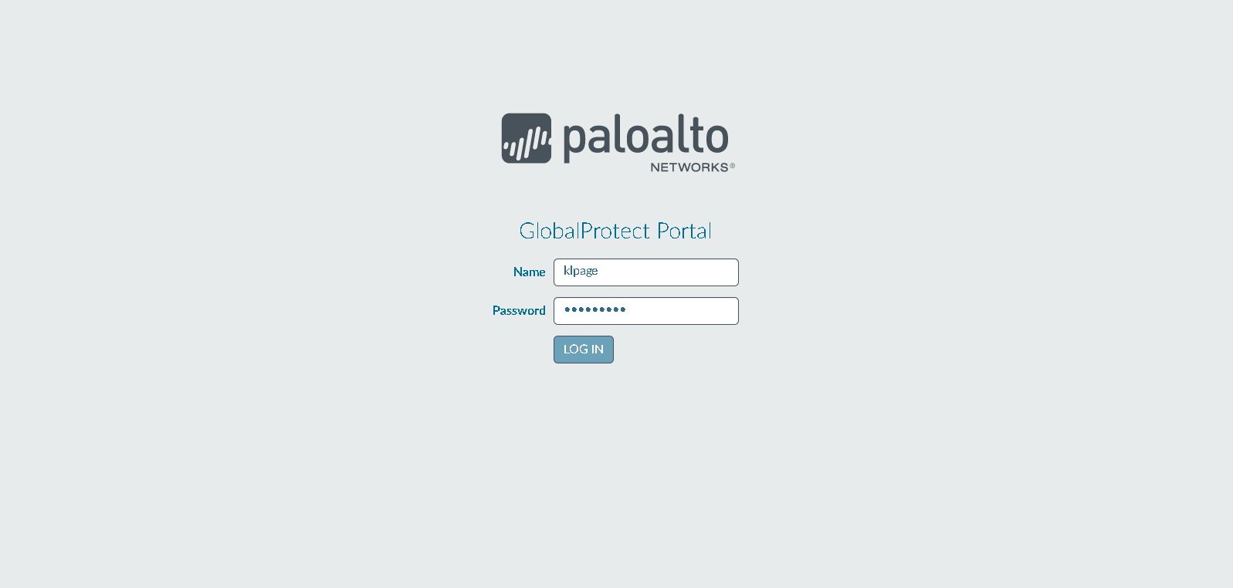

Step 3: You will receive a text message to your mobile phone
Example: 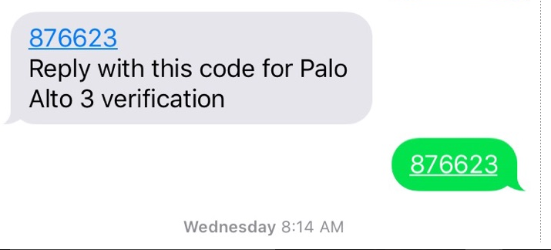

Step 4: Client download Page
Step 5: Choose the client for the OS you’re running

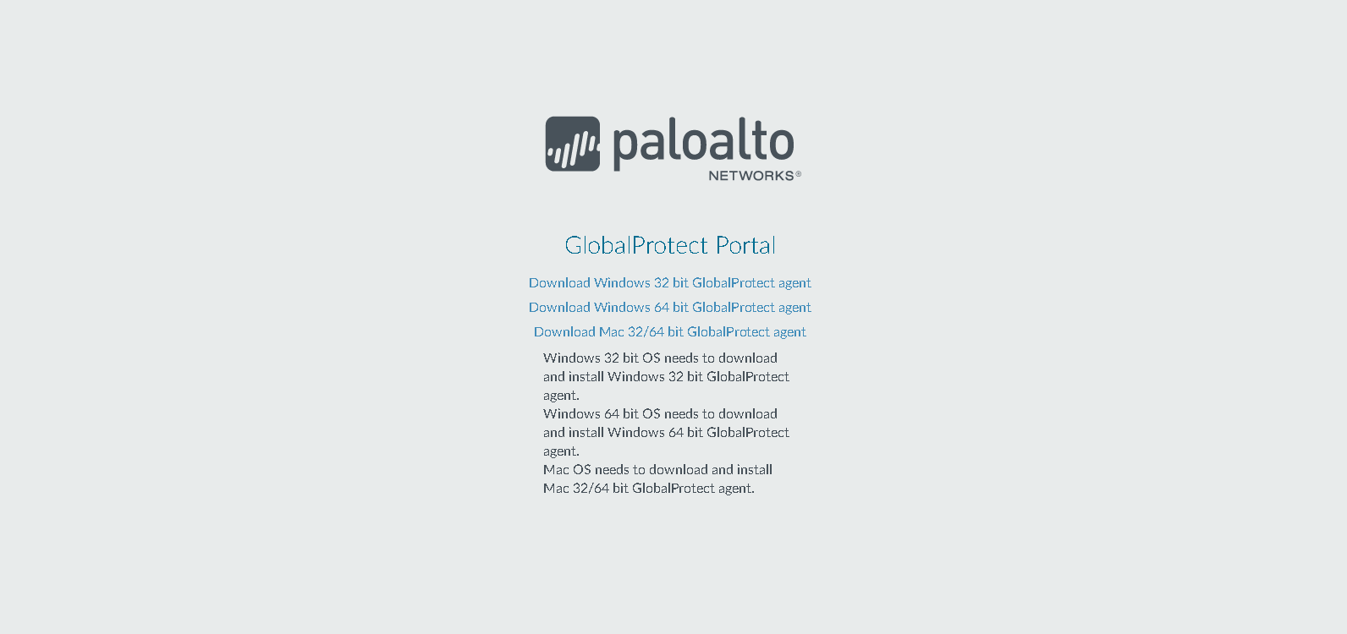

Step 6: Install Client
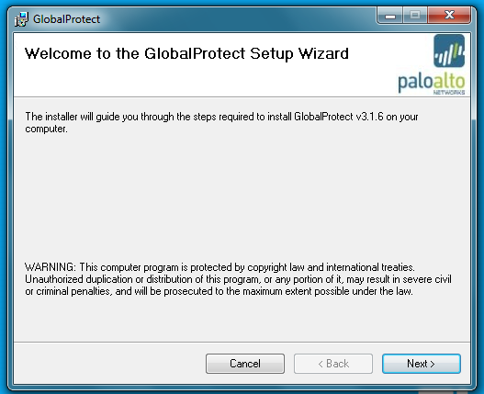
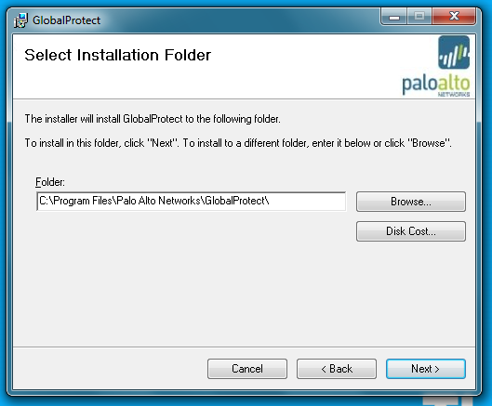
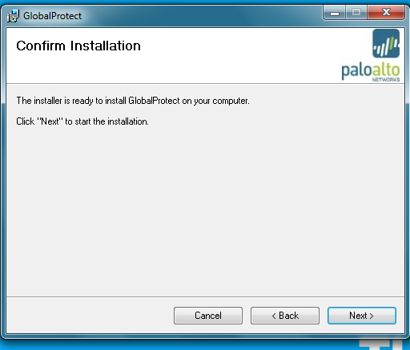
Step 7: Click on Global Protect Client
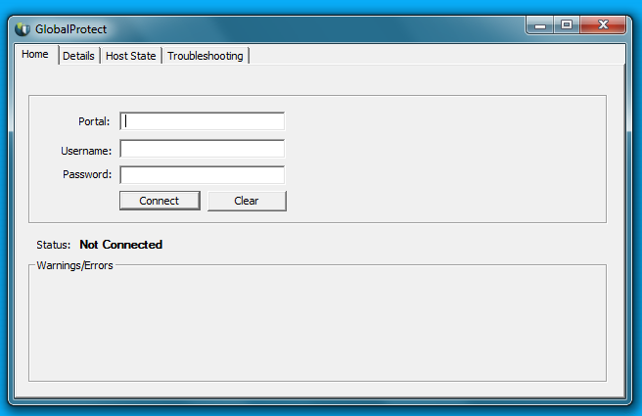
Step 8: Enter in Portal name: coaconnect.atlantaga.gov and Login with your Network Credentials
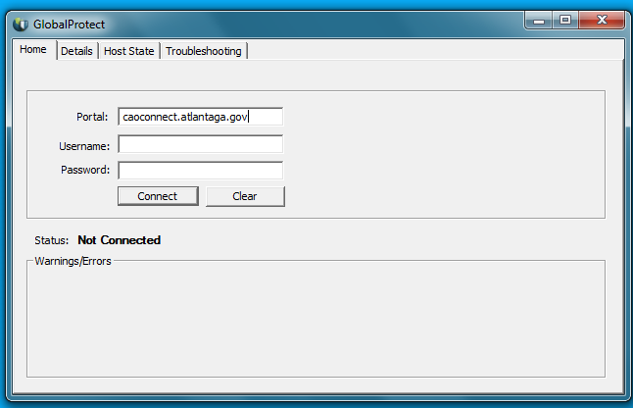
Step 9: Same as Step 3
Step 10: You are now connected to the VPN

