

Department of Information Technology

Enterprise Service Desk
Operational Manual 2014

City of Atlanta

Document Reference
Title | Department of Information Technology
Document Author | Lateef Ashekun
Document Reviewers | DIT Management team
Creation Date | 4/18/2014

Document Change History
Version | Date | Description of Change
V1.0 | 4/18/2014 | Initial draft
V1.1 | 2/11/2015 | Updated Operational Manual (Enterprise)

Service Desk Operational Manual
Team Mission
Provide world class customer service in all interactions. Comprehend the customers’ needs and work with them to provide the best solutions available via efficient utilization of people, processes and technology.
Operational Plan Summary
The Service Desktop Support Team forty seven (47) positions; 1 Director, 3 Managers, 3 Supervisors and 40 technicians/analysts servicing 8900 customers, 165 sites, 6336 PCs/Laptops, 453 Mobile tablets and an average of 4344 service tickets monthly. The Operational Manual aligns with the Standard Operating Procedure, except the operations manual delves in detail the day to day activities as it relates to the provision of IT Support listed below:
Incident Management/Service Requests - (SPOC – Single Point of Contact for all IT related issues utilizing the HEAT and NUMARA System)
Mass Communications – communicate to COA customers regarding system outages, system maintenance and other IT related emergency matters.
PC Infrastructure Support (Desktops, laptops, mobile tablets, docking stations, monitors, Virtual desktops/thin clients, etc.)
Printer/Copier Infrastructure Support (Network and Desktop printers, scanners, fax machines, etc.)
Applications Support (Standard operating systems, standard applications “Tier 1”, etc.)
Standard Operating Environment (Pertinent application of system updates and patches)
Lifecycle Management (Assets, Configuration Management, Procurement, Disposal/Recycling, etc.)
Other End User device support (Video-conferencing, Projectors, flash drives, peripherals, accessories, etc.)
IT Procurement – Responsible for procurement of all end user devices and associated IT items.
IT LIAISON RESPONSIBILITY
- DIT IT liaisons are the primary contact to City of Atlanta.
- The IT liaison should understand the role and business of their respective divisions as it relates to all technology business needs.
- When there is an IT issue or need (s) in a division, The IT liaison is responsible for communication with the manager as well as other colleagues in DIT depending on the business need. Each IT liaison should also have a primary liaison within each division to ensure constant and consistent communication. This process enables one point of contact from each area and helps to streamline the process and cut down on duplicate efforts.
- Regular Meetings: To ensure that proper communication is occurring, the IT Liaison will schedule regular meetings with the division liaison. However, the IT liaison should at least sit in one of the division’s team meetings once every 4 – 6 weeks. It is important to have these meetings and be prepared to discuss any outstanding issues.
- Initiative: The IT Liaison should also understand each division’s business need enough such that recommendations can be made to ameliorate the division’s needs via technology.
- Budget: Each IT Liaison should understand the budget so that as DIT develops its yearly budgets, the departmental liaison will be instrumental in ensuring that IT is aware of all new initiatives and/or enhancements to current configuration.
Customers
Our customers are categorized into two groups. Internal and External customers.
Internal Customers – All City of Atlanta employees that require any IT support on and off premises.
External Customer – Vendors, contractors, consultants, etc. that conduct business on behalf of the City of Atlanta.

Desktop Support Services
Standard Hardware
Hardware falls into the following categories – Standard Desktops and Laptops, High-End Desktops and Laptops. DIT created a PC infrastructure configuration document “Device Catalog” that explicitly details the specifications for the aforementioned device categories based on customer role/functionality. The PC infrastructure brands are Lenovo/Dell based with a few Apple Macintosh devices for specific roles. Mobile device brands are Apple IPads and the Microsoft Surface tablets; however, DIT is testing android based tablets.
Hardware Lifecycle Support:
Equipment evaluation/assessment/recommendations
Procurement
Delivery
Inventory received assets
Installation/Image and Configuration
Deployment
Maintenance, on-site break/fix and replacements
Various Tiers of technical support and proper assignments/escalation
Asset retirement (end of life), proper disposal policy, including hard drive sanitization in compliance with the security policy

Hardware/Equipment Refresh
Desktop/Laptops – DIT recommended a five-year lifecycle for desktops and four-year lifecycle for laptops and mobile tablets. During the annual budget cycle and business planning phase at COA, each business unit is responsible for allocating costs for all IT requests, the desktop support technicians/analysts and other resources within DIT assist the business units with recommendations and guidance on procurement of IT hardware, software and services as referenced in the summary above. The service desktop support team has estimated prices for all types of IT equipment and software that might be potentially requested in the device catalog.
Service Desktop Support Team is responsible for planning and executing the equipment refresh with minimal interruptions to business productivity of our customers.

Standard Software
The desktop support team is responsible for image development, management and support. The images are currently stored on a server ensuring periodic updates. Our responsibility as it relates to software is the applications that are part of the standard image (Adobe Flash player,
Adobe Reader, Cisco VPN Client 5.0.07.090 (Laptops only), Cisco NAC agent, Java, Mcafee 8.8, Mcafee Agent (Frame package), Microsoft Office 2010, CD authoring tools (PowerDVD, Roxio), and other applications as required. However, for licensed applications and free software requests from customers, the tickets are assigned to the applications team accordingly since they are responsible for Software and License management.

Software refresh/upgrades
The desktop support team gets direction from the applications team regarding the latest versions of the standard image applications and executes the upgrades accordingly. The desktop support team also conducts a software inventory prior to any PC replacements/upgrades using automated tools.

Hours of Availability
Our business hours are 8:15 AM to 5:00 PM, Monday through Friday with no exceptions.
On-call staff availability for after-hours support 7 days a week.

Internal SLA Violations
We devised a process to ensure that all desktop support technicians adhere to the SOP/SLA. If a technician violates the daily ticket/customer updates, that technician assumes on-call responsibility for the following week; the regularly scheduled on-call technician ends up being off. Also, team member sends out friendly reminders daily to ensure that all DIT employees are adhering to the SLA/SOPs. The responsible manager handles the technicians from other groups that violate the SLA/SOPs.

Daily Review of HEAT/NUMARA Ticket requests and other services
Each week, there is a designated call monitoring technician/analyst/supervisor who is primarily responsible for ensuring tickets details are accurate, proper categorization, call type, priority, call status and assignment.
Daily, the manager is required to send out reports showing technicians that violated the SLAs and the daily customer/ticket update requirements
Weekly, the manager is also responsible for reviewing the customer surveys and conducting service recovery as applicable.
Daily the desktop support team is required to strengthen relationships with the COA customers and alter the DIT perceptions positively.
As tickets are assigned the technicians/analysts are required to contact the customer to acknowledge receipt of the ticket and establish and estimated time of completion within the established SLA for response.
If a desktop support technician is unable to contact a technician for ticket assignment, he/she is required to contact the manager, if manager is unavailable, contact the service desk manager and if the service desk manager is not available contact the Director.

Customer Responsibilities
Adhere to all the IT Policies set forth by the Department of Information Technology
Manage their own data on their PCs with a strong recommendation advising customers to store data on the network drives (Q: (group shared) and U: (personal)) and not their hard drives.
Contact the DIT service desk for all IT incidents and inquiries via the mediums listed below:
Self-Service Web Portal
Service desk Telephone (404.382.4070 | 404.330.6474 | 404.546.1396)
Service desk Email (ISDHELPDESK@ATLANTA-AIRPORT.COM , DITHelpCenter@atlantaga.gov , Dit-Helpdesk-Water@AtlantaGa.Gov )
WALK BYS/ON-SITE (This is not encouraged)
Acquisition/Replacement of supplies, IT accessories, consumables (ink, paper, toner, etc.) as applicable.

New IT Requests
All requests for new hardware and software are requested during the budget planning/compilation annually by the various COA departments. All other items not requested within the budget require the completion and approval of an IT business justification form by the designated senior management professional of the applicable business unit. Once the business justification has been approved the customer is required to open a service desk ticket for the request.
Budget requests include the following below:
Department/Organization
Business Unit
IT request Description
Type of request (Add/Replace)
Explanation/Justification
Quantity
Estimated Unit Cost
Total
Approval Status (DIT only)
DIT Notes (DIT only)

“New” Service Level Agreements (SLA)
Priority | Incident | Acknowledgement | Response | Resolution
1 | - Issue of the highest importance--mission-critical systems with a direct impact on the organization (Examples: widespread network outage, telecom system outage, internet web page not accessible, etc.)  Single customer|group|location| outage that is preventing the affected customer(s) from working (Examples: failed hard drive, broken monitor, continuous OS lockups, etc.) | Immediate – 5 minutes | 15 minutes | 60 minutes
2 | - Single customer or group outage/disruption that can be permanently or temporarily solved with a workaround (Examples: malfunctioning printer, PDA synchronization problem, PC sound problem, etc.) | 15 minutes | 30 minutes | 24 hours
3 | - Routine planned and unplanned issues/work (Examples: new HW/SW installation, website updates, new user account creations)  - Nonessential issues/incidents (Examples: office moves, telephone moves, equipment loaners) | 30 minutes | 3 hours | 72 hours
4 | - Service Requests “Project” | 30 minutes | N/A (Applicable to negotiated expetations with customer/user) | Timely manner (dependent on factors customer, vendors, parts, etc.)

Indicators and Benchmarks
- The average amount of time between ticket received and assignment
- The average amount of time between ticket assignment and acknowledgement
- The average amount of time between ticket acknowledgement and problem resolution
- The average amount of time between problem resolution and ticket closure
- The average amount of time between ticket received and problem resolution
- Top 10 customers requesting technical support
- Number of calls per division (DIT Rep Report)
- Total number of tickets received
- Total number of tickets closed
- Total number of tickets resolved within the SLA
- Percentage of tickets resolved within the SLA
- Percentage of customers satisfied
- Total number of incidents per individual teams
- Call abandonment, telephone wait times
- Total number of First Contact Resolution (FCR) tickets daily/weekly/monthly

Strategic KPIs/Metrics
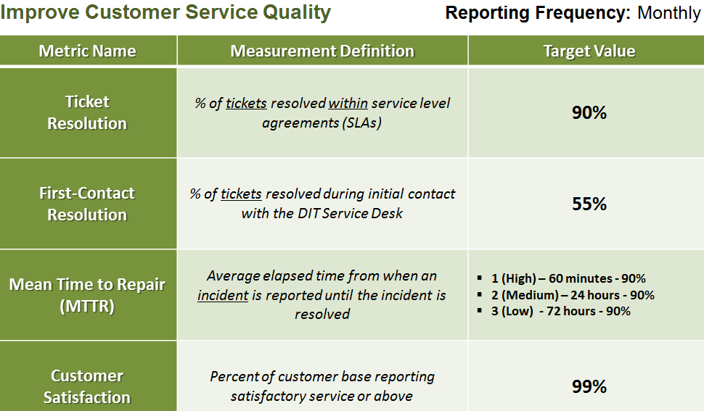

Gap Analysis
System Management tools – Automate primary tasks such as OS and applications deployments, software inventory, etc.
Incident Management System – Existing System does not meet our requirements to function efficiently and effectively aligning with IT service management best practices.
Staffing – We currently have 4 vacant positions soon to be filled, 10 requested new positions. We have been operating short staffed for a long period.
Process Improvement – We are currently improving some of our processes and ensuring proper documentation for tasks we do.

Service Desk Steering Committee
Service Desk governance group that crafts strategic initiatives and align them with the overall business priorities of DIT and City of Atlanta “Mayoral Priorities”

Function
Responsible for providing executive leadership in the development of standards, policies, and the prioritization of various initiatives applicable to the enterprise service desk operations.
The service desk steering committee will provide a stabilizing influence so organizational concepts and directions are established and maintained with a visionary global view. The Steering Committee provides direction on long-term strategies in support of DIT/COA’s mandates and business vision. Members of the Steering Committee comprise of executives, management and potential/influential leaders within the enterprise service desk to ensure that DIT/COA’s IT needs and objectives are being adequately addressed. Synopsis of activities below:
- Identify and develop strategic initiatives
- Prioritization of initiatives
- Monitor and review initiatives at regular Steering Committee meetings
- Develop and review standards and policies
- Update standards and policies as necessary
- Quality assurance of deliverables
- Facilitate buy-in across the organization
- Act as a sounding board “communication”
Major Initiatives Ongoing and Planned (Template)
Initiative Title i.e. Acquisition of desktop/laptop hardware infrastructure (PC Refresh) by April 2015
Desired Outcome
The objective is to procure and deploy new PC’s to accommodate the devices that have reached end of lifecycle (five (5) years) in the environment

Benefits
- Increased productivity for customers
- Reduced IT support costs
- Improved service levels
- Cutting edge technology
Leadership
- IT Service Desk – Lateef Ashekun
Support
- IT Service Desk
- IT Business Administration
- IT Business Applications
Resources Required
- Cost: $ 0.00 (included in DIT FY14 & FY15 budget)
- IT Desktop Support Technician(s)
- IT Business Administrator
- IT Analyst/Programmer

Strategic Priority Supported
- Employees – Employee Engagement and Satisfaction
- Customers – Enhance and Deliver Best-In-Class Customer Experience
- Finance – Preserve the Airport’s Financial Health
- Future – Future – Focus ATL for the Future

Sponsor/Owner/End User
- Service Desk – Lateef Ashekun

SERVICE DESK SUPPORT CONTINUITY OPERATIONS PLAN (COOP)

Essential Functions Description and Priority

Function | Description of Function | Priority | RTO
PC infrastructure Availability/Support | Ensure availability of PC infrastructure and required support | 1 | 15 Minutes
Copier/Network Printer Infrastructure | Ensure availability of Printer/Copier infrastructure and required support | 2 | 15 Minutes
Incident Management System (HEAT | NUMARA) | System utilized for managing all IT incidents, service requests, change management, asset management | 2 | 60 minutes
Other potential End User devices (Projectors, Scanners, etc.) | Ensure availability of other end user devices and required support | 3 | 60 minutes

Vital Records, Systems and Equipment

Essential Function | Vital Record | Equipment or Systems | Networks or Servers that must be Operational to Support the Critical System or Equipment | Description | Form and Type of Record or System | RTO
Service desk Supervisor | Heat/Numara System Records | Laptop, Mobile phone, printer and Air Card | COA Network Access  Heat Server, VPN | Communication medium for IT announcements and Support COA customers IT issues | Electronic; Active | 0 – 4 hours
Service desk Technician | Heat/Numara System Records | Laptop, Mobile phone, printer and Air Card | COA Network Access  Heat Server, VPN | Support COA customers IT issues | Electronic; Active | 0 – 4 hours

Orders of Succession
Essential Function | Key Personnel | Successor 1 | Successor 2 | Successor 3
Manage/Supervise Helpdesk operations | L.Ashekun | M.Tanks | D.McCrary | D.Hughley
Helpdesk Technician/Analysts | Desktop Support Personnel | M.Thompson | J.Myers | E.Coe

Delegations of Authority
Authority  (Function) | Type of Authority | Position Holding Authority | Delegation to Position | Triggering Conditions | Procedures | Limitations
Mass Communication Messages | Unrestricted privilege to send mass emails | Supervisor | Helpdesk Technician | Unavailable | Internal Policy | Upon return of the incumbent
Inventory Receipt | Signature Authority | Supervisor | Helpdesk Technician | Unavailable | Internal Policy | Upon return of the incumbent
Procurement | Signature Authority | Supervisor | Helpdesk Technician | Unavailable | Internal Policy | Upon return of the incumbent

Requirements for Alternate Facilities

Essential Function | Number of Personnel | Back -up Power | Communications | Space Requirements
Service desk Supervisor responsibilities | 2 | Required | Laptop, Mobile phone, printer and Air Card
Service desk technicians responsibilities | 46 | Required | Laptop, Mobile phone, printer and Air Card

Alternate Facilities Options
Facility | Address | Agreement | Date Executed | Security | Secure Storage Available? | Special Notes
C4 | 720 Doug Davis Drive, Hapeville, GA - 30354 | Not applicable |  | Will be available on-site | To be provided by the Network Services Team
Technical Campus | 1255 South Loop Road, College Park, GA 30337 | Not applicable |  | Will be available on-site | To be provided by the Network Services
Leased Facility within 30 – 60 miles | Unknown | None |  | Will be coordinated accordingly | To be provided by the Network Services

Resource Requirements for Essential Functions
Essential Function | Essential Personnel and Back-up | Vendors and External Contacts | Vital Records | Equipment | Systems | RTO
Helpdesk Supervisor responsibilities | Melvin, Donnie, Darrius |  | Heat/Numara System Records | Laptop, Mobile phone, printer and Air Card | DOA Network Access  Heat Server, VPN | 0 – 4 hours
Helpdesk technicians responsibilities | J.Myers, M.Thompson, and E.Coe |  | Heat/Numara System Records | Laptop, Mobile phone, printer and Air Card | DOA Network Access  Heat Server, VPN | 0 – 4 hours

DIT CALL CENTER/HELPDESK FLOW (HEAT)

DIT CALL CENTER/HELPDESK FLOW (NUMARA)
