

Department of Information Technology

Standard Operating Procedures
For
Enterprise Service Desk

City of Atlanta

Document Reference
Title | Department of Information Technology
Document Author | Lateef Ashekun
Document Reviewers | DIT Management team
Creation Date | 4/18/2014

Document Change History
Version | Date | Description of Change
V1.0 | 4/18/2014 | Initial draft
V1.1 | 2/11/2015 | Updated SOP (Enterprise)

Table of Contents

1.OVERVIEW
1.1 BACKGROUND
1.2 Document Purpose
1.3 RESPONSIBLITIES OFSERVICE DESK MANAGER/SUPERVISOR
1.4 RESPONSIBILITIES OF SERVICE DESK/DESKTOP TECHNICIAN/ANALYST
2. DESKTOP SUPPORT PROCEDURES
2.1.1 Section Purpose
2.1.2 it requests - process/procedure
2.1.3 call center triage matirx
2.1.4 DIT team interaction

2.2 DIT Call Center Process Flow

OVERVIEW

BACKGROUND
The Department of Information Technology (DIT) provides a broad range of IT services to its customers (Aviation Services, Watershed Management Services, City Operations Support, Public Safety and Justice, and Asset and Citizen Services. DIT develops and maintains the City’s IT infrastructure, provides technical assistance and guidance as well as effective customer service driven IT support all in alignment to the City Priorities.

In order to support the COA Strategic objectives, DIT is organized such that it can provide the best IT services possible. Service Desk acts as the face of DIT as it is the first line and single point of contact for most internal and external customers.

DOCUMENT PURPOSE
This document focuses on the functions of the Service Desk Team. This document also provides the Service Desk Support Team Members and DIT as a whole with guidelines, written procedures for carrying out their daily operational duties.

RESPONSIBILITIES OF SERVICE DESK MANAGER/SUPERVISOR:
Provides day to day supervision of the Service Desk Team. Provides work assignments to the Team in response to the organization’s Strategic Plans, Business Plans and service requests directed by emerging problems or new projects. Conducts mid-cycle and annual performance development reviews. Manages service level requirements and tracks performance relating to Standard Operating Procedures. Provides reports and recommendations relating to the quality of service provided to customers; thus continuously improving on customer satisfaction. Researches and provides recommendations for hardware and other peripheral devices to meet customer needs while maintaining business standards. Advises on and facilitates the ordering of all equipment relating the desktop and peripherals. Prepares budget projections and monitors expenditures for requested budget. Provides hiring recommendations to the Director of IT.

RESPONSIBILITIES OF SERVICE DESK ANALYST/TECHNICIAN:
The responsibilities of the Service Desk Team include:

    - Desktops, Laptops, PC Tablets, Mobile Devices, Printers, Computer imaging and software installation
    - Customer Service, Incident Assignment, Call Tracking, Ticket Prioritization, Incident Resolution/Follow-up

Service Desk Analyst –The Service Desk Specialist’s primary responsibility is to provide quality customer service to all users, provide technical support to the City of Atlanta Departments in a timely, professional and efficient manner. Manage all end user support issues, including logging tickets in Numara/heat system, assigning, escalating and tracking all support related issues from initial contact to final resolution.
The Service Desk responds to and troubleshoots all end user support requests and follows up to ensure that satisfactory resolutions are provided. This includes but is not limited to password resets, printer connectivity, network connectivity, email problems, new account request, and provide first level application support.

Desktop Support Technician - The Desktop Support Technician’s primary responsibility is to work with a variety of users to resolve any problems as it relates to their computers and peripherals. Some of these problems consist of installing, configuring, assisting and supporting of authorized software and hardware and to perform some system administrative duties. Their duties also include capturing all IT requests whether by phone, email, or Technician, and entering detailed information into HEAT/NUMARA system for processing. Other responsibilities include updating the HEAT/NUMARA database with current customer information, prioritizing, categorizing, and assignment of tickets. The Desktop Support technician also manages the relationships with customers while service is being provided.

Service desk procedures

Section Purpose

This section provides an overview of how services are delivered to the Department of Information Technology and its contractors from the Service Desk Team. It provides the Department of Information Technology with procedures for recording and responding to tickets logged in the Heat system from internal customers.

The main purpose of this section is to help ensure that the Service Desk Team delivers an effective customer-focused function to all internal customers. To do this, customers will be required to contact the Service Desk for all IT related services. This will enable the Service Desk Team to prioritize the calls received which will also help to ensure that a high quality of service be given to all customers.

IT requests – process/procedure

Requests for IT Services
Customers are asked to make requests for IT services to the service desk Center via:
Service desk Telephone (404.382.4070 | 404.330.6474 | 404.546.1396)
Service desk Email (ISDHELPDESK@ATLANTA-AIRPORT.COM , DITHelpCenter@atlantaga.gov , Dit-Helpdesk-Water@AtlantaGa.Gov )
Self Service Portal (SharePoint/Intranet)

When answering the phone, the service desk analyst/technician will respond with: “Thank you for calling the DIT service desk, this is {name} speaking. How may I exceed your expectations today? OR How may I assist you today? The service desk analyst/technician will provide the customer with a ticket number shortly after greeting the customer at the beginning of the call. This is done so that in the event that the call is prematurely interrupted, the customer will be able to call back and continue by referencing the ticket number. The service desk analyst/technician will then proceed to gather information about the request from the customer.

Verifying Customer Information
After gathering information about the customer’s request, the technician will verify the following:

- Customer’s first and last name
- Customer’s network account username
- Phone number and extension
- Exact location
- Detailed problem statement
- PC or device serial#/asset tag (if applicable)

After the information has been gathered, the Service Desk Personnel will follow procedures as listed below.

Determining the Service Being Requested
The service desk provides customers with four overarching IT services; these are Break Fix, Informational, IT Procurement, and Scheduled. Break Fix Service refers to providing support for any IT hardware or software that is either not functioning properly or adversely affecting our customer’s productivity. Informational Service refers to providing our customers with instruction on how to use City of Atlanta issued hardware or software or answering basic IT related inquiries. IT Procurement Service refers to ordering IT equipment/service needed for our customers to perform their duties. Scheduled Service refers to fulfilling any IT request that can be planned in advance. IT Request Service refers to service requests for moves, adds or changes (MACs)

The Service Desk personnel will determine the service being requested based on the information gathered at the beginning of the call.

Determine Priority, Category, Type and Item
The Help Desk Specialist or Desktop Support Technician will assess the impact and urgency of the issue on the customer and set a priority for the call by referring to the Call Center Triage Policy, which defines call response and resolution times depending on the type and severity of the call. The Technician will also determine the category, type and item (CTI) of the call by matching the customer’s initial problem statement to one of the entries listed in this Foot Prints system.

The different CTI groupings are defined as follows:
- Category: Used to identify a fairly generic grouping of issues.
- Type: Used to route the request to the appropriate team.
- Item: Identifies asset to be addressed.

Assigning Technical Resources
Once the priority, category, and type of request have been determined, the Service Desk Personnel will be assigned to the request as the “assignee” and will then make every attempt to resolve the issue themselves. If the service desk is able to resolve the issue the status will be changed to resolve and the customer updated.

If the Service Desk Personnel is unable to resolve the issue and additional resources are required, they will then inform the customer of the status, ensure that the customer has the ticket number. The ticket will then be routed to the appropriate team based on the CTI selection that was made at this time. The new assignee will provide updates to the customer and is responsible for the resolution, escalation and closure of assigned tickets.

Each Team is responsible for ensuring that all incidents that are assigned to their Team members are acknowledged, updated and closed according to the Call Center Triage Policy.

Assignment Routes
Tickets will be assigned to team members by one of the following methods.

System assigned Round Robin - The FootPrints/Heat system is configured to assign ticket to team members one after another in order to available techs.

Team Lead – the Service Desk Personnel will assign tickets to the Team Lead that has been designated by that team’s manager to govern the assignment of tickets to the team. The service desk personnel will ensure the ticket is placed in the queue for the designated team member.

Resolving the Issue
When a technician receives notification of a call assignment, the technician will first, contact the customer to establish and estimated time of completion and update the footprints tickets system. Next, the technician will attempt to resolve the issue within time frame indicated in the SLA.

The technician will make every attempt to resolve the issue using remote diagnostic or management tools such as Remote Desktop, Numara Service Core, etc… Only after determining the issue cannot be resolved remotely will the technician travel to the customer location. If the Technician determines that the issue cannot be resolved with any available resources, the Technician will make a journal entry in the call and arrange vendor support.

Ticket Updates
Any ticket that needs to remain open for an extended period of time will be updated at three day intervals. The technician will contact the customer by close of business that day and provide a status and an estimated time of repair. The technician will update their respective ticket journals with information detailing the date and time of any customer contact, steps taken to resolve, any status update provided to the customer, and the estimated time of repair given to the customer.

If the ticket is open and no activity is taking place for reasons outside of the technicians’ control, the ticket will remain open but be placed Pending Customer status until such time the customer has provided the necessary information to proceed. Tickets that are on-hold due to lack of availability of the customer will be updated and closed after three business days.

Ticket Resolution & Closure
Tickets will be “Resolved” when the customer requesting service has had their issue resolved to their satisfaction and agreed upon.

Ticket closure conditions:

- Any necessary components have been replaced or repaired and any equipment in question has been restored to its original state of readiness.
- A suitable workaround is provided to the customer.
- The initial problem statement captured in the beginning of the call has been updated (if necessary) and resolved.
- The customer has been unavailable for three business days (document ticket accordingly)
- The customer has determined that a satisfactory resolution has been implemented

Technicians will contact customers and resolve tickets after the above mentioned conditions are met.

Tickets will be “Closed” after a period of 5 business days has passed after being “Resolved”

SERVICE DESK Center Triage Matrix

Triage Background
During emergency medical situations involving multiple patients, the medical staff must quickly decide which patients need immediate attention and which ones can wait. While the problems we face as technicians are seldom life-or-death affairs, being able to rapidly choose the problem that needs the quickest response is a must for running an efficient, effective IT support organization. To ensure service desk personnel make these critical decisions both swiftly and accurately, a call center triage policy has been developed.

Triage Matrix Purpose
This matrix ranks potential problems by level of importance. The ranking scheme takes into consideration the problem's effect on business-critical systems, the number of systems affected by the problem, the number of customers affected by the problem, and how the problem is affecting customer productivity. The following indicators are used to determine how a ticket is triaged:
- Impact: The number of people in the organization who are impacted with these levels:
  - Enterprise–wide
  - Department/Bureau-wide
  - Location- or Office-wide
  - Individual Only

- Urgency: The severity of the incidence as it relates to the ability to complete work with these definitions:
  - Work Impaired: A customer is considered work impaired when they can partially consume one IT service. For instance, if they can print, but can only print on the color printer.
  - Degraded: A customer is considered degraded when they are unable to consume an IT service at all. For instance, in the example above, a customer who is unable to print at all would be considered degraded.
  - Down: A customer is considered to be down if they are unable to consume any IT services at all, and thereby unable to work.

Triage Matrix

Under normal operations, support will be given on a first-come, first-served basis and issues will be addressed in the order in which they are received. However, the following ranking scheme should be used to categorize all requests for assistance, and to prioritize requests when more than one has been assigned to a technician. Additional consideration may be given to remote customers. The contact and resolution times given below are the Information Services Division’s general guidelines under normal circumstances. During extraordinary situations, such as a natural disaster, prolonged power outage, or other catastrophic events, contact and resolution times may be longer. ~ The matrix below shows the relationship between impact and urgency.

URGENCY | IMPACT
 | HIGH | MEDIUM | LOW
HIGH | CRITICAL | HIGH | NORMAL
MEDIUM | HIGH | MEDIUM | LOW
LOW | LOW | LOW | LOW

NEW SLAs (IN CHANGE MANAGEMENT PROCESS)
Priority | Incident | Acknowledgement | Response | Resolution
1 | - Issue of the highest importance--mission-critical systems with a direct impact on the organization (Examples: widespread network outage, telecom system outage, internet web page not accessible, etc.)  Single customer|group|location| outage that is preventing the affected customer(s) from working (Examples: failed hard drive, broken monitor, continuous OS lockups, etc.) | Immediate – 5 minutes | 15 minutes | 60 minutes
2 | - Single customer or group outage/disruption that can be permanently or temporarily solved with a workaround (Examples: malfunctioning printer, PDA synchronization problem, PC sound problem, etc.) | 15 minutes | 30 minutes | 24 hours
3 | - Routine planned and unplanned issues/work (Examples: new HW/SW installation, website updates, new user account creations)  - Nonessential issues/incidents (Examples: office moves, telephone moves, equipment loaners) | 30 minutes | 3 hours | 72 hours
4 | - Service Requests “Project” | 30 minutes | N/A (Applicable to negotiated expetations with customer/user) | Timely manner (dependent on factors customer, vendors, parts, etc.)

Metrics | KPIs
Weekly statistics will be produced and published on the Desktop Support Team to provide information about the volume of calls opened and closed during the week. A breakdown of the types of calls being placed to the Call Center and individual assignee statistics will also be published.

The information provided will include:

- The average amount of time between ticket received and assignment
- The average amount of time between ticket assignment and acknowledgement
- The average amount of time between ticket acknowledgement and problem resolution
- The average amount of time between problem resolution and ticket closure
- The average amount of time between ticket received and problem resolution
- Top 10 customers requesting technical support
- Number of calls per division (DIT Rep Report)
- Total number of tickets received
- Total number of tickets closed
- Total number of tickets resolved within the SLA
- Percentage of tickets resolved within the SLA
- Percentage of customers satisfied
- Total number of incidents per individual teams

Strategic KPIs/Metrics
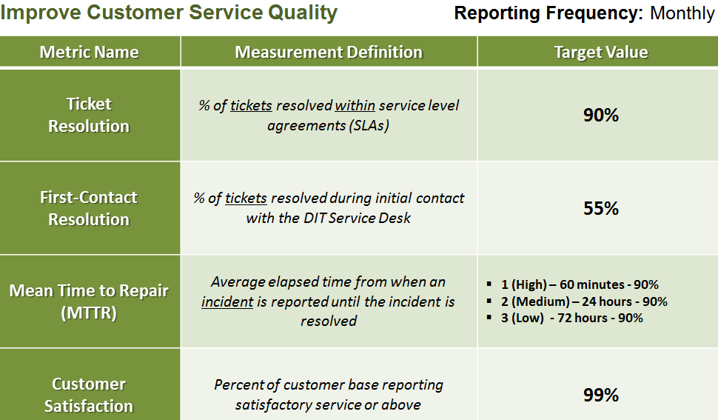

Operational KPIs/Metrics

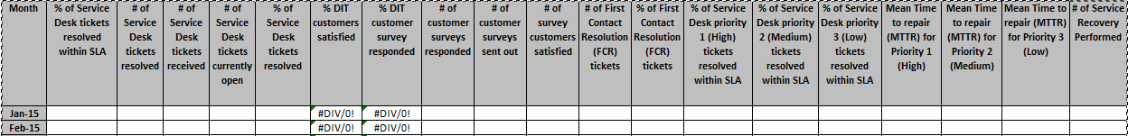

Continuance
This policy is a living document and may be modified at any time through a collective agreement between members of the Department of Information Technology.

Summary
This policy is designed to act as a guideline for providing customer oriented professional IT services to all Department of Aviation internal customers. This enables the Department of Information Technology to achieve its business objective which is to support the City of Atlanta’s mission. Full cooperation and adherence to this policy is appreciated and needed so that all goals can be met in accordance with the business objectives.

DIT team interaction
The DIT Help Desk maintains relationships with all teams within DIT. Teams will be called upon to resolve incidents in which they are the SMEs for systems that they maintain that are not necessarily supported by the Desktop Support Team. Some teams do not receive incident requests, but help is sometimes required from the SMEs/administrator for the respective applications/systems.

Applications
Any customer requiring assistance pertaining to any outages/issues for the systems in which this team supports (Please see the DIT Triage document)

Business Administration
All procurement requests not limited to service calls and the purchase of IT equipment
Requests for surplus

Business Applications
Software installation requests approval
Any customer requiring assistance pertaining to any outages/issues with the systems in which this team supports (Please see the DIT Triage document)

Program/Project Management
Any customer requiring assistance pertaining to any existing or new projects.
Any customer requiring assistance pertaining to any issues with applications/systems that this team has implemented.

Infrastructure Design and Development
Any customer requiring assistance pertaining to any outages/issues with the systems in which this team supports (Please see the DIT Triage document)

IT Operations
Any customer requiring assistance pertaining to any outages/issues with the systems in which this team supports (Please see the DIT Triage document)

Software Design
Any customer requiring assistance pertaining to any outages/issues with the systems in which this team supports (Please see the DIT Triage document)

DIT CALL CENTER/HELPDESK FLOW)

DIT CALL CENTER/HELPDESK FLOW (NUMARA)
